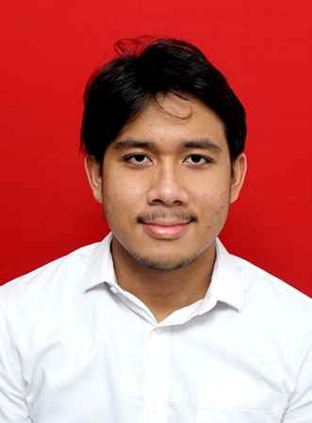

Sessario Ammar Wibowo

Bekasi, Jawa Barat, 17110 **|** +62 878 873 56115**|** Sessario.aw@gmail.com

Linked in: linkedin.com/in/sessario-ammar-wibowo/

Portofolio: bit.ly/SessarioAmmarWibowo

**About Me**

I am Sessario Ammar Wibowo, a 5th semester Computer Science student at Bina Nusantara University. I have been a part of the Binus English Club(BNEC) organization for 2 years. Currently, I am the president of BNEC Bandung where I supervise multiple events, such as seminars, new member recruitments, and more. I am passionate about working as a full stack developer.

**Skills**

|  |  |
| --- | --- |
| * Java * C * JavaScript * Python | * React * Laravel * PHP * Flask |

**Experience**

**Binus English Club(2019-Now)**

*Staff Learning Management* (February 2022-February 2023)

* Managed class schedules, finding tutors, and making TOEFL questions
* Additionally, handled documents relating to the management of TOEFL classes

*President of BNEC Bandung* (February 2023-Now)

* Supervise 2 key divisions, Learning management division and Brand and Public Affairs division. Delegating tasks efficiently and ensure that there is no problem.
* Supervise key events such as seminars, new member recruitments and more.

**Education**

**Universitas Bina Nusantara** **(2022 - Now)**

*S1 Computer Science - GPA 3.66*

* A member of KRTI competition group that represents Bina Nusantara
* Handled badminton tournament to send teams to represent Binus Bandung
* Joined Badminton Competition to represent Binus Bandung
* President of BNEC Bandung
* Member of curiosity lab

**Chung Yuan Christian University** **(February 2023 - June 2023)**

*Score 83/100*

Virtual study abroad program at CYCU Taiwan by taking Mathematical Programming course as a substitute for Calculus course at BINUS University

**SMA Jakarta Islamic School (2018 - 2021)**

*Major IPA*

* The Vice President of student council, handles events for school and supervise other students

**Projects**

***Respitune***

A web-app that deploys deep learning model to recognize 4 different respiratory problems by analyzing wheezes and crackles pattern in breathing audio. The project was built in Flask and MySQL

***IBalance***

A web-app that deploys a simple machine learning model to measure client’s stress tolerance level so they could find the right company for themselves. This project was built in PHP vanilla

***Stalker***

An autonomous drone that follows target that has its face recognized, additionally this drone can be manually controlled. This project was built in Python and DJTello Drone.